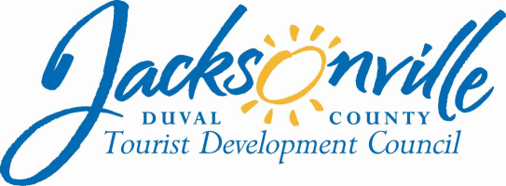

OFFICE OF THE CITY COUNCIL

Annette R. Hastings 117 WEST DUVAL STREET, SUITE 425
TDC EXECUTIVE DIRECTOR 4TH FLOOR, CITY HALL

OFFICE (904) 630-7625 JACKSONVILLE, FLORIDA 32202

FAX (904) 630-2906
E-MAIL: ANNETTEH@coj.net`

A G E N D A

TOURIST DEVELOPMENT COUNCIL ADVISORY COMMITTEE
Pegine Echevarria, Chair
Wednesday, January 17, 2018
2:00 P.M.
117 West Duval Street
City Hall, Fourth Floor
Conference Room A

TDC Advisory Committee Members
Pegine Echevarria, Chair
Nicole Chapman-Excused
Barbara Halverstadt-Excused
Maria Hane
Dave Herrell
Bill McConnell-Excused
Maria Mark
Sean Satya-Excused
Monica Smith-Excused
Alan Verlander

Annette Hastings, TDC Executive Director
Colleen Hampsey, Research Assistant
Kim Taylor, Assistant Council Auditor
Phillip Peterson, Principal Council Auditor
Lawsikia Hodges, Deputy General Counsel

Meeting Convened Meeting Adjourned:

I. Call to Order
II. Introductions
III. TDC Advisory Committee Charge/Council President Anna Lopez Brosche, TDC Chair
In accordance with Ordinance Code Section 666.108, the Tourist Development Plan, and specifically stated in Ordinance Code Section 666.108(b)(5) related to special event grants, please prepare guidelines and procedures for awarding special event grants that the Tourist Development Council may use as a framework for providing for the advancement, generation, growth and promotion of tourism, enhancement of the tourist industry, attraction of conventioneers and tourists from within and without the State of Florida to the City of Jacksonville. These guidelines are intended to serve as criteria for considering and awarding special events grants and should be developed with the intention of facilitating the highest and best use of taxpayer dollars to increase tourism.

IV. Establishment of Special Events and Convention Grant Guidelines under 2016-599-E
Special Event grants. This component shall authorize the Tourist Council to award special event grants to organizations or persons hosting an event in the City or surrounding areas. Any event funded under this component shall have as one of its primary purposes the attraction of tourists to the City as evidenced by the promotion of such event to tourists. This component shall be limited to the following grants:
(i) Grant awards for attendance of 25,000 tourists or 10,000 room nights or greater. The Tourist Council may award grants for special events designed to attract a minimum of 25,000 tourists to the City, which grant award may not exceed $250,000 for any such event unless currently obligated by contract until such obligation expires; and
(ii) Grant awards for attendance of 5,000 tourists or greater for events held at publicly owned venues. The Tourist Council may award grants for special events designed to attract a minimum of 5,000 tourists to the City using publicly owned tourist venues such as the arena, performing arts center, or stadium or at the zoo or eligible museums. Such grant awards may not exceed $100,000 per event.
Task Force Responsibilities
- What do the Request for Proposals process need to stipulate?
- What are the evaluation guidelines to receive payment from the grant?
V. Public Comments
VI. Closing Comments
- TDC Advisory Committee Meeting –January 22, 2018
VII. Adjourn
***Other Items may be added or deferred at discretion of the Chair. ***
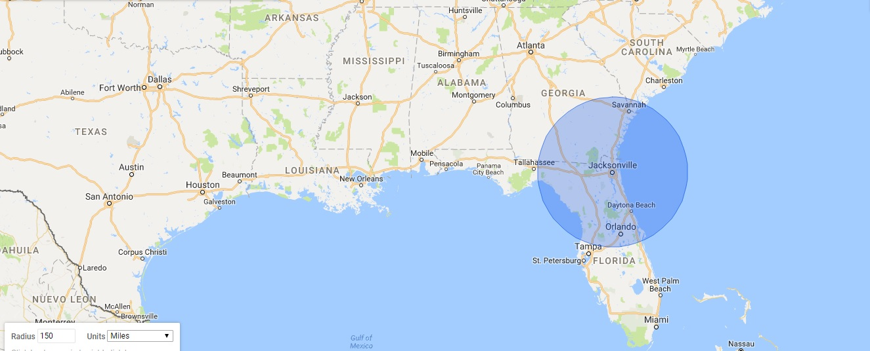
150 Mile Radius from Jacksonville Florida

